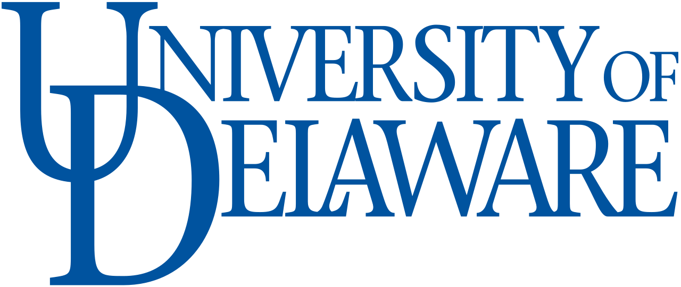
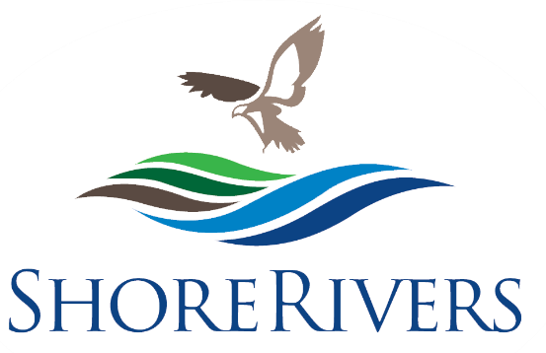

ShoreRivers and University of Delaware
Internship Program
Chestertown and Galena, 2024

ShoreRivers seeks applicants for an exciting, hands-on summer internship experience in the environmental field, based in the Chester and Sassafras watersheds. This internship program is provided through a partnership with the Delaware Environmental Institute at the University of Delaware.

ShoreRivers is a nonprofit organization that protects and restores Eastern Shore waterways through science-based advocacy, restoration, and education. With offices in Easton, Chestertown, and Galena Maryland, the organization serves as an advocate for the health of our rivers and the living resources they support. Our programs promote environmental awareness of the essential role local rivers and streams play in the community, the issues that threaten their health and vitality, and solutions that must be implemented to preserve them.

The summer intern will provide programmatic support for our Chester River and Sassafras River programs and participate in a variety of activities including restoration, water quality monitoring, outreach, education, and enforcement. By the end of the program the intern will have completed a Maryland boater safety certificate, become familiar with handling a boat, gained experience and training in scientific water quality monitoring equipment and protocols, and developed a variety of other skills and experiences.

Program Logistics
Location This internship is based in the Chestertown and Galena offices, with fieldwork across the Chester and Sassafras watersheds, and occasional travel throughout the ShoreRivers region
Dates Minimum of 10 weeks between May and August; start and end dates and vacation days are flexible
Hours Monday-Friday, 8:30-4:30; with occasional evening and weekend work
Stipend $5,000 provided by University of Delaware through the Carski-Ruhl Giving Fund
Housing Available at Washington College Student Housing if needed

Program Requirements
- Outgoing personality with good communication skills. Must be able to work with a team, but also be self-motivated in individual tasks.
- Able to lift at least 50 lbs, swim, feel comfortable on boats and kayaks, and do physical outdoor activity in various weather conditions.
- Willing to work a flexible 40-hour schedule with some evening and weekend hours.
- Rising college junior or senior, or recent college graduate. Degree in Biology, Environmental Science, or related field encouraged.
- Proficient in Microsoft Office software.
- Must have a driver’s license.

Intern Responsibilities
- Obtain a Maryland boater safety certificate
- Tidal water quality monitoring by boat with Riverkeepers
- Water Chestnut eradication work on the Sassafras
- Bacteria sampling at local swim sites
- Submerged aquatic underwater grass monitoring by kayak
- Co-leading community kayak tours
- Community outreach and events
- Agricultural site visits and project monitoring
- Boat and water quality equipment maintenance

Application Process
Current University of Delaware students should apply through the Undergraduate Research Portal no later than March 1, 2024. Before applying, please visit ShoreRivers.org to learn more about our organization and our programs.
Interviews will be conducted by Zoom in and an intern will be selected and notified no later than March 22, 2023.

ShoreRivers believes that swimmable, fishable, clean, and safe rivers are for everyone in our communities. ShoreRivers is an equal opportunity employer and welcomes all applicants.

